Tasks for the team:
1. Prepare for the daily stand-up and sprint Backlog planning by understanding the
meeting design (what needs to be done, by whom), creating a fictional
Scrum/Kanban board to illustrate the situation, and dividing the roles.
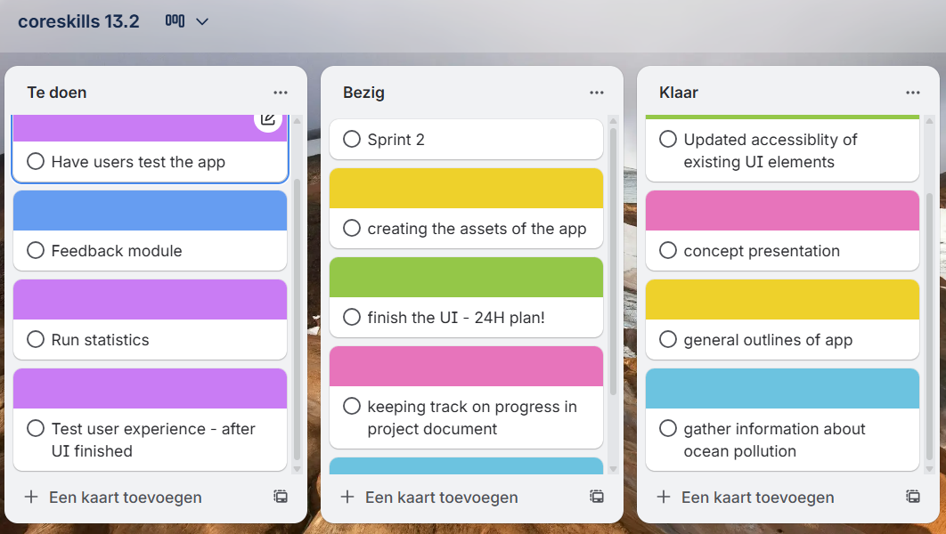

2. Explore: What makes a good stand-up answer? (think of the outcomes) And why
must stand-ups be short?

3. Which feedback model could be used (SBI, DESC, Sandwich, SSC), and how could
you apply it to provide respectful feedback in this situation?

Feedback "script":
Feedback Giver: “it seems you haven’t been able to finish your part of the project yet, you told everyone last stand-up you’d have the ui finished by the next one, yet it still is unfinished”
Feedback Receiver: “I’ve had a tough time adding and polishing some parts, I’m running into some issues.”
Feedback Giver: “Because of this I haven’t been able to work on my part, which has slowed down our overall progress. If you need help just ask, I’d be willing to help you finish the UI”
Feedback Receiver: “Thank you, I’d love some help seeing as I fear I might not be able to finish it otherwise”
Feedback Giver: “then that’s settled”

4. Which (Thomas–Kilmann) conflict resolution style could you use?
Collaboration. By helping eachother, both of the developers can work on their designated task.

5. Prepare at least one rhetorical example (Ethos/Pathos/Logos) to justify accepting or
rejecting the PO’s new request.
Based on our team’s past delivery patterns and our commitment to maintaining reliable, high-quality features, adding a new mechanic mid-sprint would compromise our standards. Scheduling it for the next sprint allows us to uphold the level of quality you expect. So I would suggest that we add the mechanic in the next sprint.

6. Each team member should also prepare for their role in the meeting.

7. The duration of the meeting is 10 minutes; for the meeting design and preparation,
you get 30 minutes.

Task list:
Fleur (Scrum master)
Ilana (Developer; Dissatisfied with progress)

Wesley
To do:
Is done:
Luke (Developer)
- Gather information about ocean pollution.
- Add the gathered information into the app.
To do:
Is done:
Troy:
To do: Finish the UI
Is done: Updated accessibility of existing UI elements
Demi: Product Owner.

Timeline
- Daily standups, clockwise everyone discusses what they have done, and what they plan to do in the next couple of days (The team member hindered by someone else goes last)

Fleur: I see the burn-down chart has barely moved since the start of this sprint, why is that.
Ilana: Well, I can’t start my task until someone finishes the UI

- Feedback, feedback is given to the one that hasn’t been able to finish their part
- Client, client walks in and request another addition
“ Could you add a small ‘ eco tip of the day functionality’ to this sprint.
- Discussion, the team members discuss the request
- Response, the team answers the request with a valid response held up by arguments
- Summary, scrum master summarized what happened

